**Mystery Skull Station**

Animal skulls can tell us many things about creatures and how they once survived in their natural environment. A few relatively simple observations of an animal’s skull can tell us **what the animal ate**, whether the animal was **predator or prey**, and which **senses** were most important to the animal’s survival. Some of the characteristics of skulls that we use to tell us about how the animals lived are explained below.

**Teeth:** The teeth in an animal skull can tell us whether the animal was a *carnivore* (meat eater), *herbivore* (plant eater) or an *omnivore* (meat and plant eater).

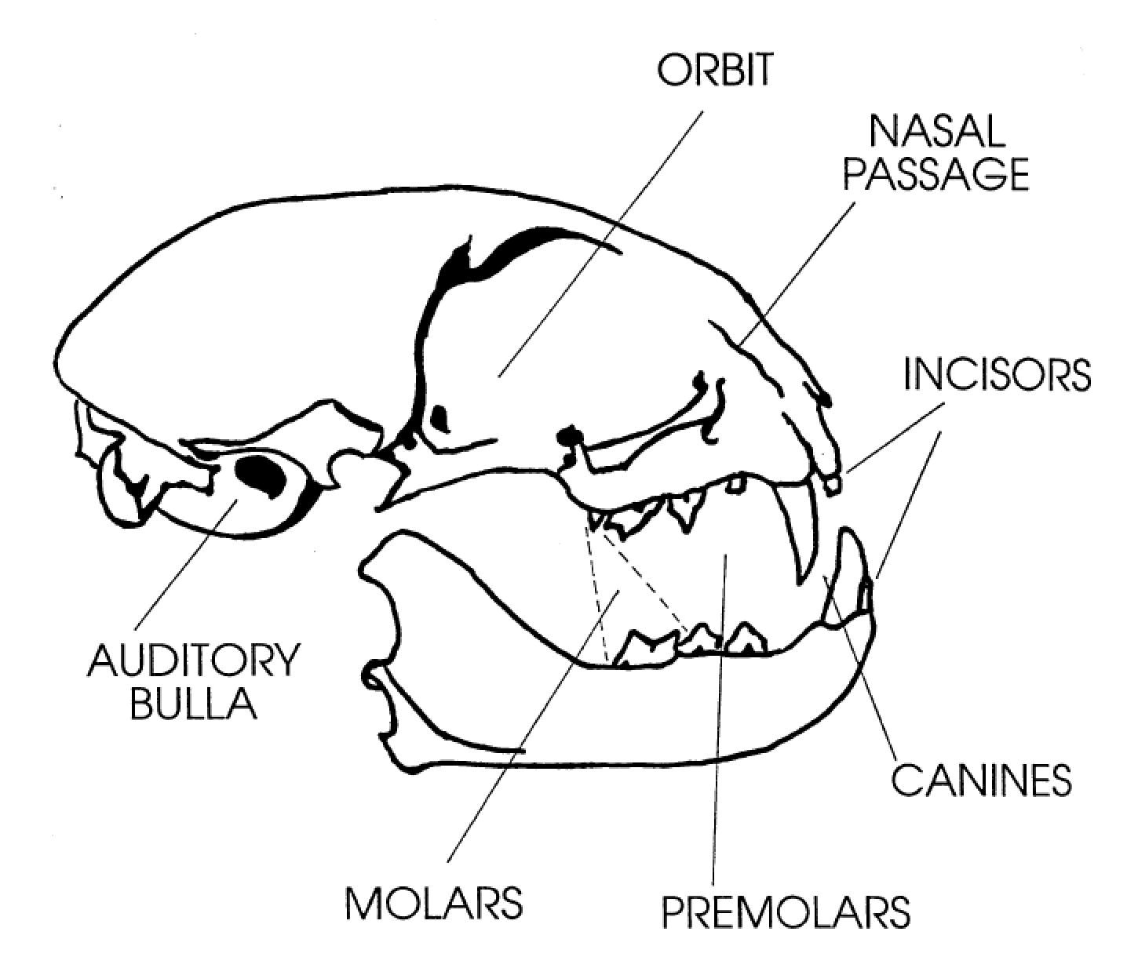***Carnivores*** have comparatively small, less developed *incisors*. *Incisors* play a minor role for carnivores such as grooming. The *canine teeth* are large, long and pointed for piercing and holding prey. Cheek teeth (*pre-molars* and *molars*) are sharp and pointed for cutting and tearing flesh. Some of the upper cheek teeth overlap lower teeth, providing a scissor-like shearing action to cut meat. These teeth are referred to as *carnassial teeth.* With overlapping cheek teeth and long *canines*, *carnivores* do not have the ability to move the lower jaw from side to side in a chewing motion. *Carnivores* are predators (they kill and eat other animals) and tend to bite, tear and gulp food without any chewing action. The meat eater’s teeth tend to be clean and white because they are not stained by plant material.

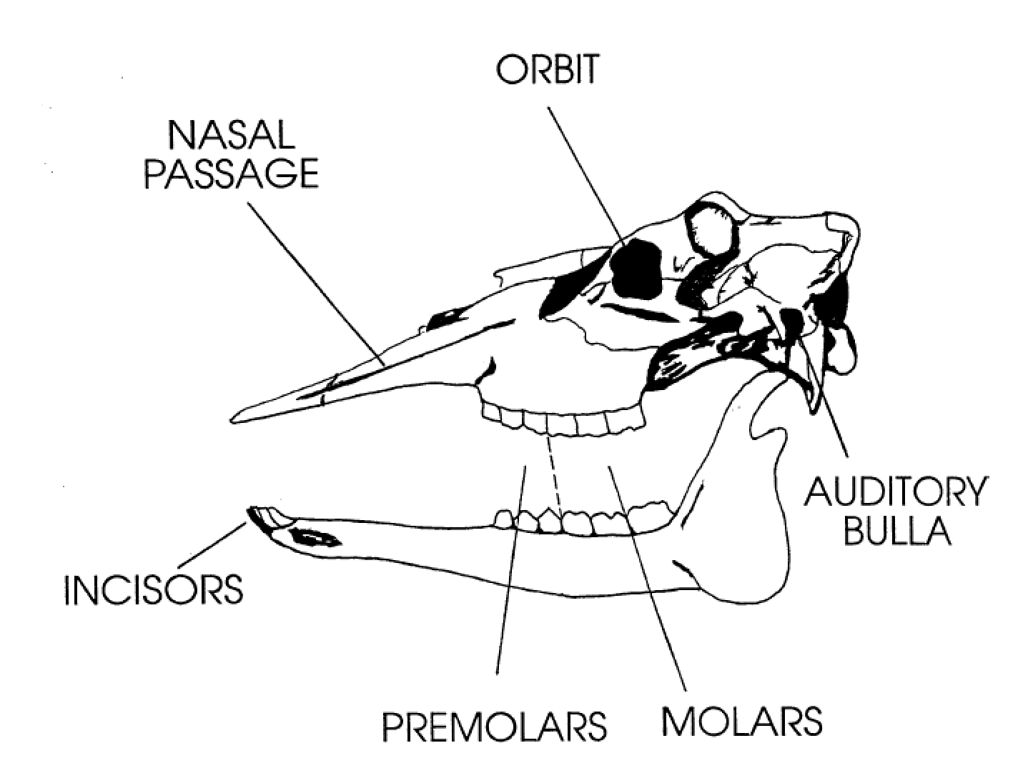

***Herbivores*** have large, well developed *incisors* for cutting plant material. Their *canines* resemble *incisors* in form and function. Most ruminant (cud chewing) *herbivores* (deer, sheep, cattle, etc.) do not have upper *incisors* or *canines*. Instead, they have a hard upper *palate* that serves as a “cutting board” for the lower *incisors* to cut through plant stems. This arrangement permits the rapid ingestion of large amounts of plant material. *Herbivore* cheek teeth are large and wide with high, sharp crowns for grinding and chewing plant material. Instead of overlapping, the cheek teeth make surface contact to provide a grinding action. *Herbivore* teeth are often stained from substances in plants.

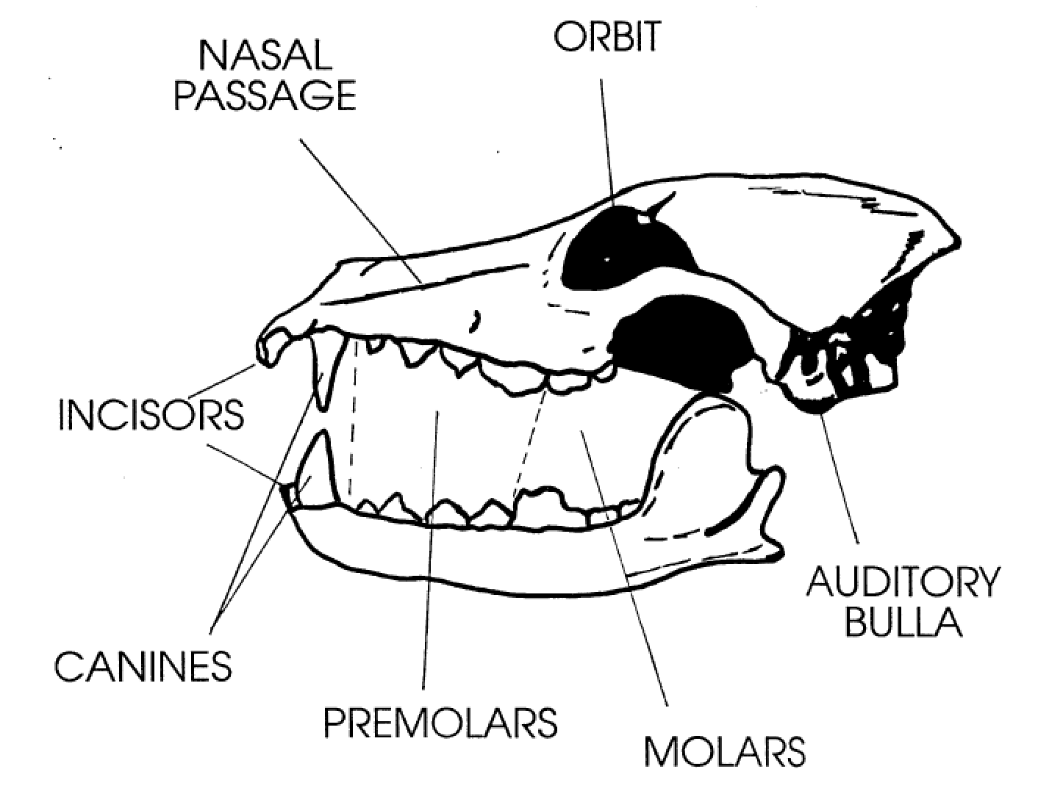***Omnivores*** have a combination of *carnivore* and *herbivore* teeth characteristics. *Omnivores* have fairly large and well developed *incisors* for cutting plant material. The *canine teeth* are long and pointed for killing and holding prey. Cheek teeth are a combination of sharp, scissor-like *carnassial teeth* for shearing meat, and teeth with more rounded *cusps* for grinding and crushing plant material. There is surface contact between some upper and lower *molars.* The cheek teeth of these animals can usually tell us their predominant feeding strategy – whether they primarily eat meat or plants. For example, the coyote is an *omnivore* that is predominately a meat eater and has cheek teeth very similar to a *carnivore.* However, the coyotes’ most *posterior molars* have rounded *cusps* for grinding and crushing plant material. On the other hand, the black bear is an *omnivore* that is predominately a plant eater and has cheek teeth more closely resembling those of an *herbivore*.

**Eyes:** The size of the *orbits* (eye sockets) in relation to the overall size of the skull, is generally proportional to the sharpness of the animal’s eyesight. The larger the *orbits*, the better the eyesight of the animal. As an example, mountain lions (and most cats) have very large *orbits* and hence, very acute vision. The large eyes of cats, and many other *nocturnal* animals, play a role in their keen night vision.

**Nasal Passage:** The relative size of the *nasal passage* on a skull is an indication of the animal’s sense of smell. The thin bony structures inside the *nasal passage* (nasal turbinates; the Mountain Lion skull contains a good example) provide the framework for membranes which sense odor. The greater the size of these structures, the greater the sense of smell. The short *nasal passages* of cat skulls tell us that cats do not have a very good sense of smell compared to many other animals and rely more on other senses to locate prey. Conversely, the long *nasal passage* of a coyote indicates that coyotes have a very keen sense of smell and that this sense is important to the coyote’s survival.

**Predator and Prey:** Predators are animals that eat other animals and prey are animals that are eaten by other animals. Predators can also become prey. When a cat eats a mouse, the cat is

predator. When a cat is eaten by a coyote, the cat is prey. Predators are always *carnivores* or *omnivores*, whereas prey may be *carnivores*, *herbivores* or *omnivores*.

When examining skulls to determine predators, we of course look for the teeth characteristics of a *carnivore* or an *omnivore*. If the teeth characteristics of a skull are strictly those of an *herbivore*, we consider the animal to be a prey species. Another skull characteristic that is very useful in determining predator/prey classification is the location of the *orbits* (eye sockets.) Most predators have the eyes located in a forward position on the skull, which provides the animal with a greater degree of *binocular vision:*  both eyes focus on an object, providing the animal with a greater ability to judge distance (depth perception). *Binocular vision* is an advantage when attacking prey and an important element of the predator’s survival. *Herbivores* are strictly prey and most have *orbits* located on the side of the skull. This placement limits *binocular vision*, but enhances the animal’s field of view or peripheral vision. These *herbivores* have *monocular vision* which means that they can see an object with only one eye. With *monocular vision*, each eye has a field of view of almost 180 degrees. Therefore, by using both eyes, these animals almost have a 360 degree field of view. This field of vision provides the animal with a greater ability to locate predators and is an important element of their survival. In some *herbivores* there is some overlap in the field of view and these animals may have partial *binocular vision*.